
NAME:
Atia Rahat (57325)
Ahmad Raza (53302)

PROGRAM:
BSSE-6

COURSE:
SQE

DOCUMENT:
WEB (PRO-SHOP)

TESTING
Black box/ White box/Manual & Automation Testing

SUBMITTED TO:
Dr. Muhammad Fawad

BLACK BOX TESTING
Login Module
Module : 1 Sign In Page
TC ID | Test Case | Test Data | Expected Result | Status
TC-01 | Valid Login | Registered email + correct password | User is successfully logged in and redirected to Home/Profile page | pass
TC-02 | Invalid Password | Registered email + incorrect password | Error message: "Invalid Email or Password" | Pass
TC-03 | Invalid Email | Unregistered email + valid password | Login fails and error message is displayed | Pass
TC-04 | Empty Email Field | Email blank + valid password | Validation message: "Email is required" | pass
TC-05 | Empty Password Field | Valid email + password blank | Validation message: "Password is required" | pass
TC-06 | Both Fields Empty | Email blank + password blank | Validation messages for both fields | Pass
TC-07 | Invalid Email Format | ahmdgmail.com | Validation message: "Enter a valid email address" | Pass
TC-08 | Password Case Sensitivity | Correct email + password in different case | Login fails | pass
TC-09 | Leading/Trailing Spaces | " ahmd@gmail.com " + correct password | Spaces are trimmed and login succeeds | pass
TC-10 | SQL Injection Attempt | ' OR 1=1 -- | Login is denied and application remains secure | pass
TC-11 | Cross-Site Scripting (XSS) Attempt | <script>alert('XSS')</script> | Input is sanitized and script is not executed | pass
TC-12 | Extremely Long Email Input | Email longer than allowed limit | Validation error or input rejection | Pass
Boundary Value Analysis
Test Case | Input | Expected Result
Minimum Length | a@b.c | Accepted
Maximum Length | 254-character email | Accepted
Above Maximum Length | More than 254 characters | Rejected
Password Field
Test Case | Input | Expected Result
Minimum Length | 1 character | According to system rules
Normal Length | 8 characters | Accepted
Maximum Length | System maximum limit | Accepted
Above Maximum Length | Exceeds limit | Rejected

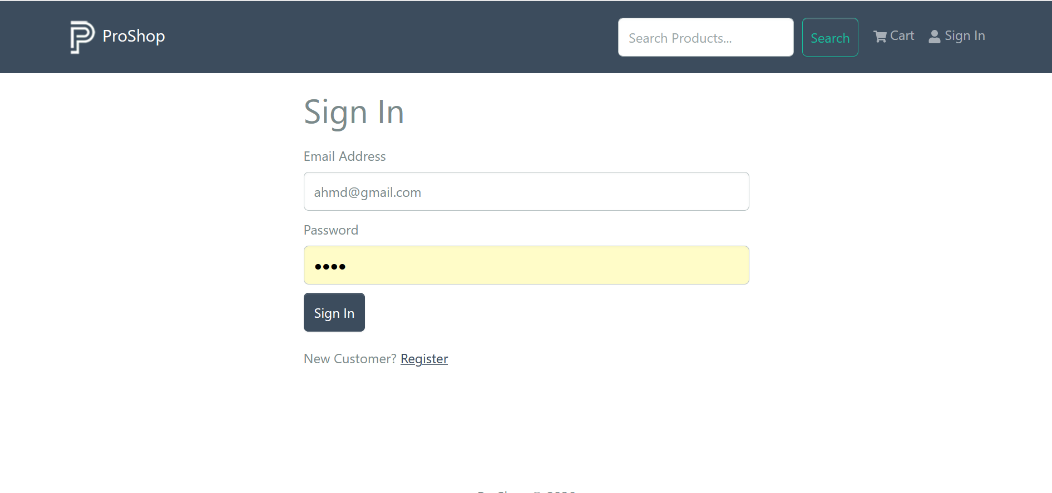
Add To Cart
Module 1: Empty Cart
TC ID | Test Case | Test Data | Expected Result
EC-01 | Open empty cart | No product added | “Your cart is empty” message shown
EC-02 | Check subtotal | No product added | Subtotal shows 0 items and $0.00
EC-03 | Checkout empty cart | Click checkout | User should not proceed
EC-04 | Go Back link | Click Go Back | User returns to products/home page
EC-05 | Refresh empty cart | Refresh page | Cart remains empty
EC-06 | Cart icon count | Empty cart | Cart count shows 0 or no badge
Module 2: Add Product to Cart
TC ID | Test Case | Test Data | Expected Result
AC-01 | Add valid product | Product with qty 1 | Product added to cart
AC-02 | Add same product again | Same product | Quantity increases, duplicate row not created
AC-03 | Add different product | Product 2 | New product row added
AC-04 | Add out-of-stock product | Stock 0 | Product not added
AC-05 | Add product with max stock | Qty = available stock | Product added
AC-06 | Add product above stock | Qty > stock | Error or quantity restricted

Module 3: Update Cart Quantity
TC ID | Test Case | Test Data | Expected Result
UQ-01 | Update valid quantity | 1 to 2 | Quantity updated
UQ-02 | Enter zero quantity | 0 | Rejected or item removed
UQ-03 | Enter negative quantity | -1 | Rejected
UQ-04 | Enter decimal quantity | 1.5 | Rejected
UQ-05 | Enter text | abc | Rejected
UQ-06 | Enter above stock | 100 | Rejected or restricted
Module 4: Remove Product from Cart
TC ID | Test Case | Test Data | Expected Result
RC-01 | Remove one item | Click delete icon | Product removed
RC-02 | Remove from multiple items | Delete one product | Only selected product removed
RC-03 | Remove all items | Delete all | Empty cart message shown
RC-04 | Subtotal after remove | Remove item | Subtotal updates
RC-05 | Cart badge after remove | Remove item | Cart count decreases
RC-06 | Refresh after remove | Refresh page | Removed item should not return
Module 5: Cart Subtotal
TC ID | Test Case | Test Data | Expected Result
CS-01 | One item subtotal | Price 599.99, qty 1 | $599.99
CS-02 | Multiple quantity subtotal | Price 599.99, qty 2 | $1199.98
CS-03 | Multiple product subtotal | Product 1 + product 2 | Correct total shown
CS-04 | Zero cart subtotal | Empty cart | $0.00
CS-05 | Quantity update subtotal | Change qty | Subtotal updates instantly
CS-06 | Remove item subtotal | Delete product | Subtotal decreases
Module 6: Proceed to Checkout / Shipping
TC ID | Test Case | Test Data | Expected Result
PC-01 | Checkout with valid cart | Product added | Shipping page opens
PC-02 | Checkout with empty cart | No product | User should not proceed
PC-03 | Checkout without login | Guest user | Redirect to Sign In
PC-04 | Checkout after login | Logged-in user | Shipping page opens
PC-05 | Back from Shipping | Browser back | Cart page shows same items
PC-06 | Removed Payment/Place Order | Payment and Place Order removed | Flow should stop at Shipping or next custom step

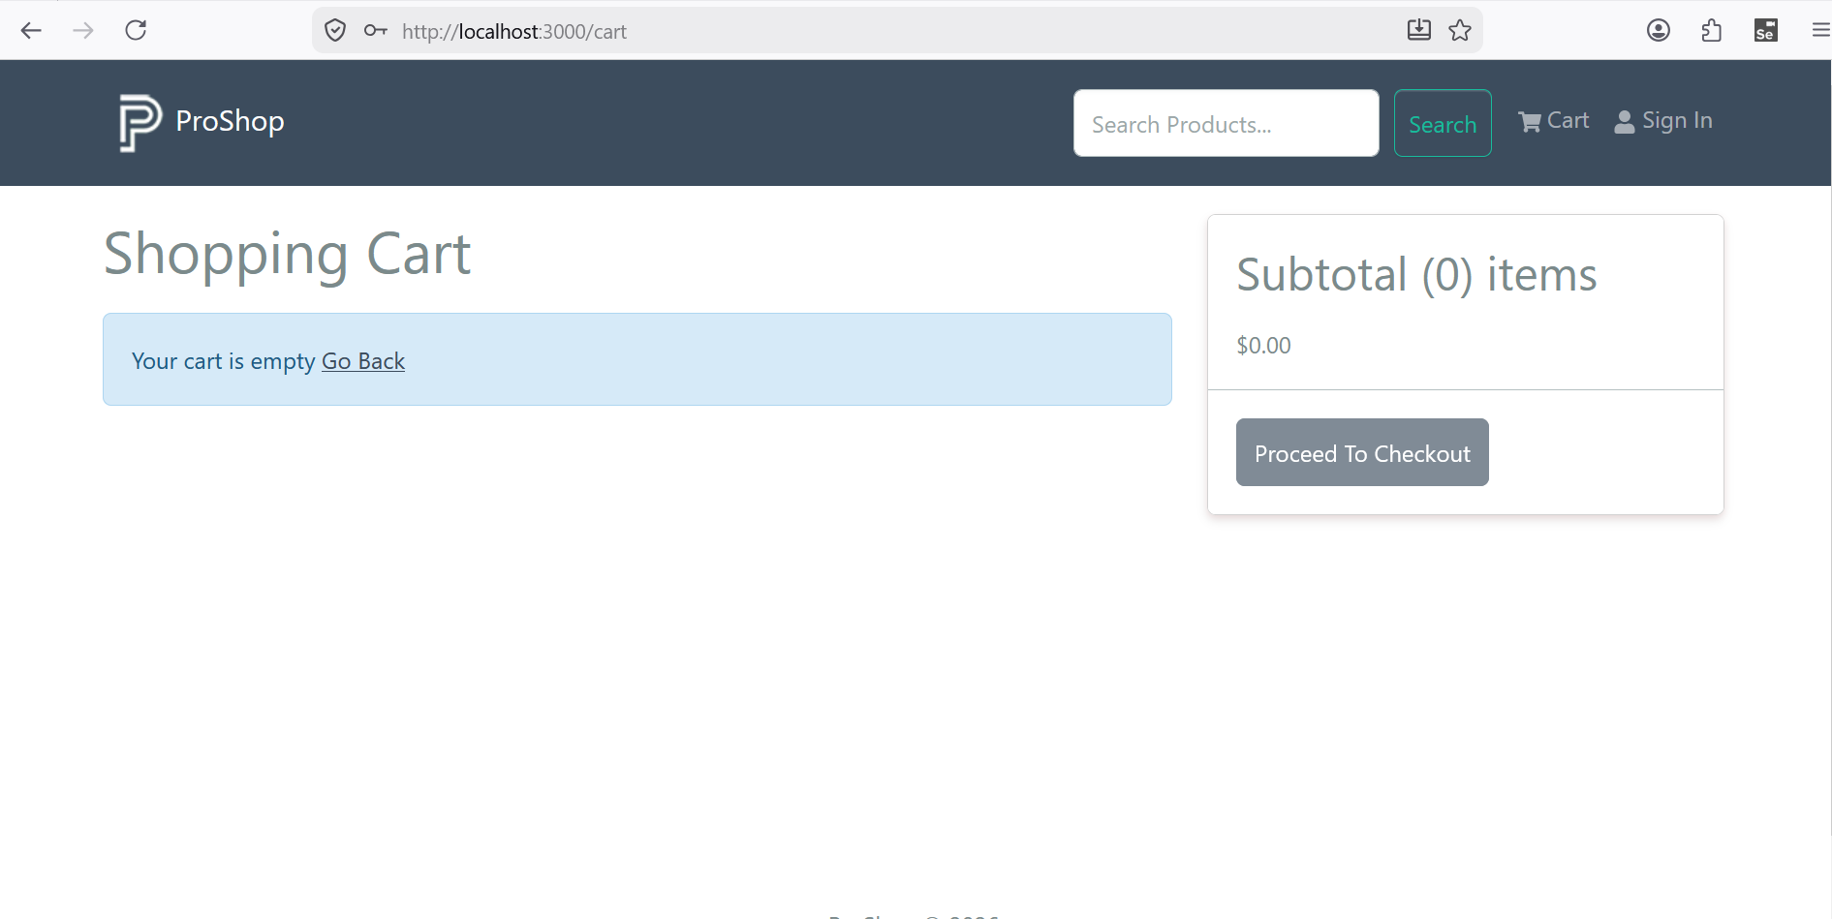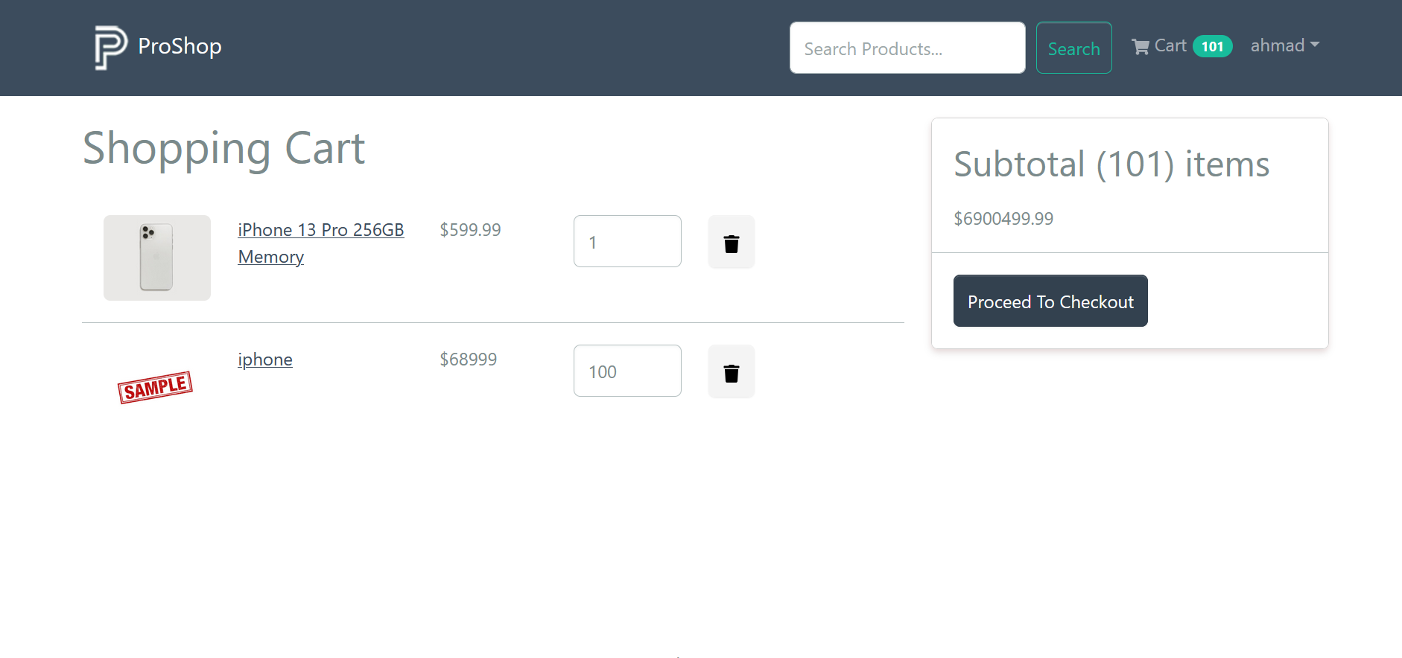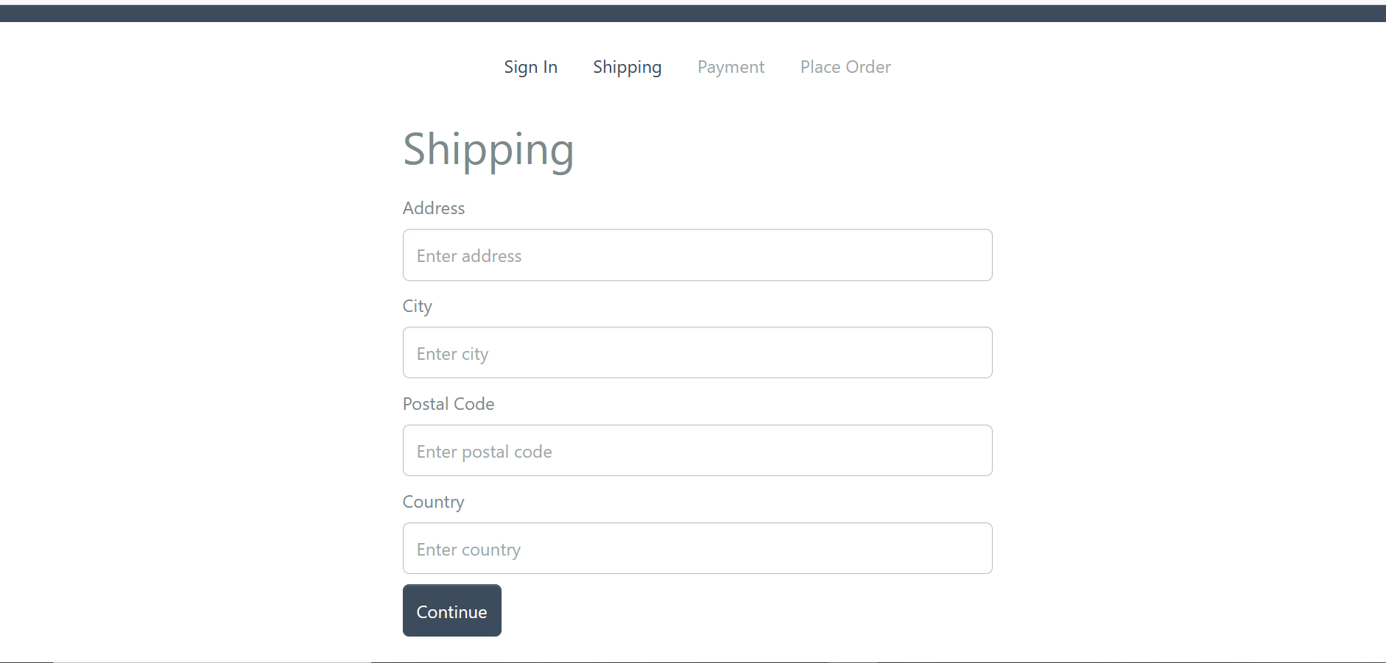
Search Product Module
Module 1: Search Product by Valid Keyword
TC ID | Test Case | Test Data | Expected Result
SK-01 | Search existing product | iphone | Matching product displayed
SK-02 | Search another existing product | camera | Matching product displayed
SK-03 | Search partial keyword | iph | Related products displayed
SK-04 | Search case-insensitive keyword | IPHONE | Matching product displayed
SK-05 | Search with spaces | " iphone " | Product displayed
SK-06 | Search exact product name | iPhone 13 Pro 256GB | Exact product displayed
Module 2: Search Product with Invalid Input
TC ID | Test Case | Test Data | Expected Result
SI-01 | Search non-existing product | xyzabc | No products found
SI-02 | Search random text | test123 | No products found
SI-03 | Search special characters | @@@ | No products found
SI-04 | Search numbers only | 12345 | No products found
SI-05 | Search SQL injection | ' OR 1=1 -- | System remains secure
SI-06 | Search script tag | script | Script not executed
Module 3: Empty Search Functionality
TC ID | Test Case | Test Data | Expected Result
ES-01 | Search empty field | Blank | Latest products displayed
ES-02 | Click search without input | Blank | No error occurs
ES-03 | Press Enter with empty field | Blank | Latest products displayed
ES-04 | Refresh page after empty search | Blank | Products remain visible
ES-05 | Empty search after valid search | Clear textbox | Latest products displayed
ES-06 | Multiple empty searches | Blank | System works normally
Module 4: Search Result Display
TC ID | Test Case | Test Data | Expected Result
RD-01 | Product image display | iphone | Image visible
RD-02 | Product name display | iphone | Correct name shown
RD-03 | Product price display | iphone | Correct price shown
RD-04 | Product rating display | iphone | Rating shown
RD-05 | Review count display | iphone | Reviews shown
RD-06 | Multiple products display | iphone | All matching products displayed
Module 5: Go Back Function
TC ID | Test Case | Test Data | Expected Result
GB-01 | Click Go Back | After search | Return to home page
GB-02 | Go Back after valid search | iphone | Previous page opened
GB-03 | Go Back after invalid search | xyzabc | Previous page opened
GB-04 | Go Back multiple times | Click repeatedly | No crash
GB-05 | Refresh after Go Back | Home page | Page loads correctly
GB-06 | Go Back after empty search | Blank search | Previous page displayed
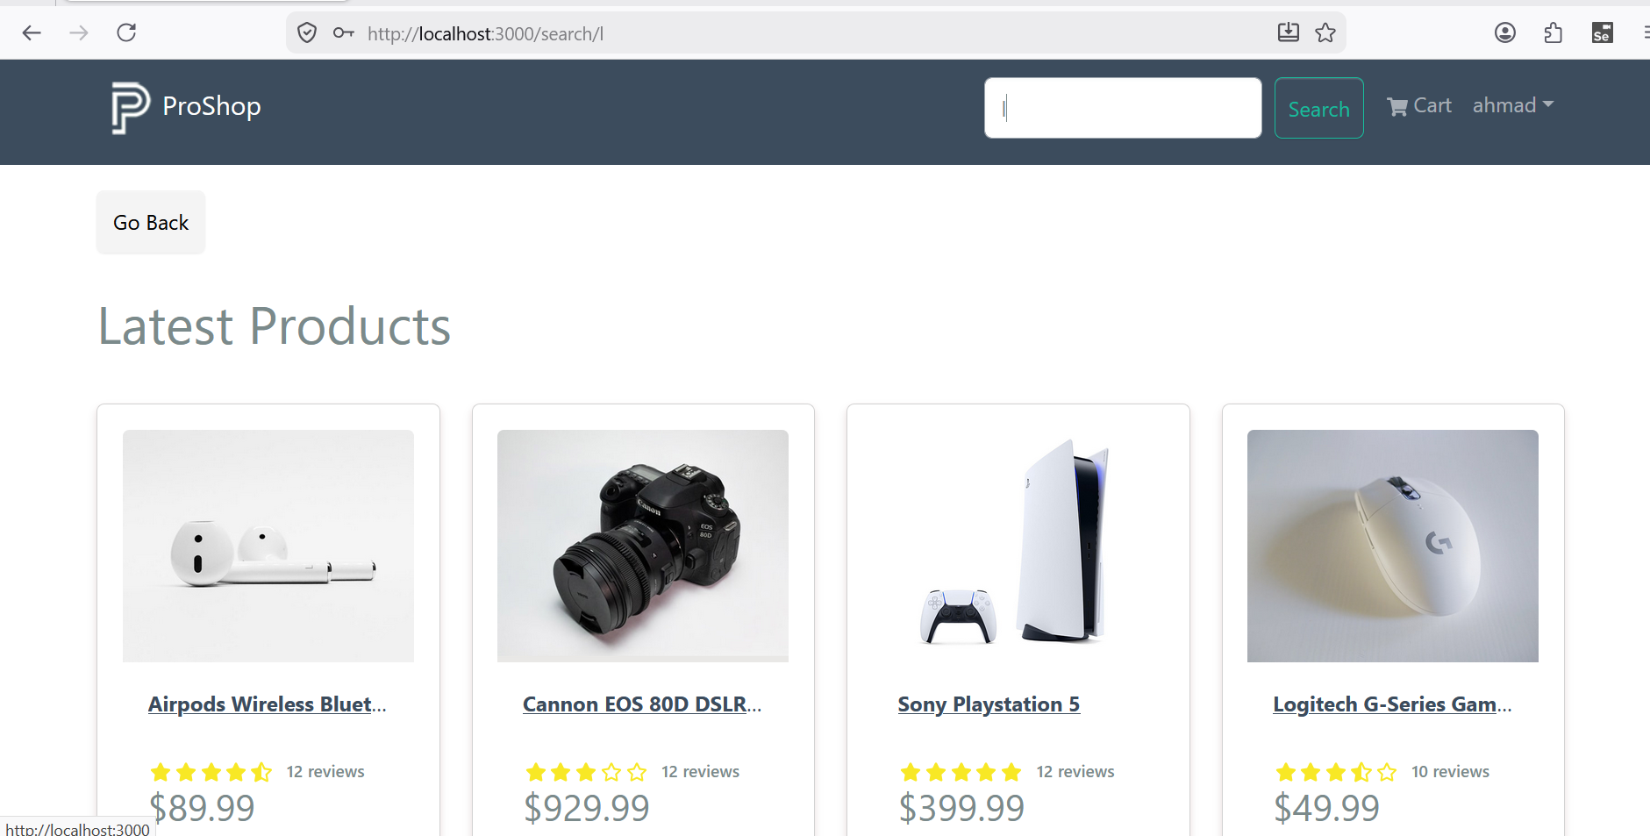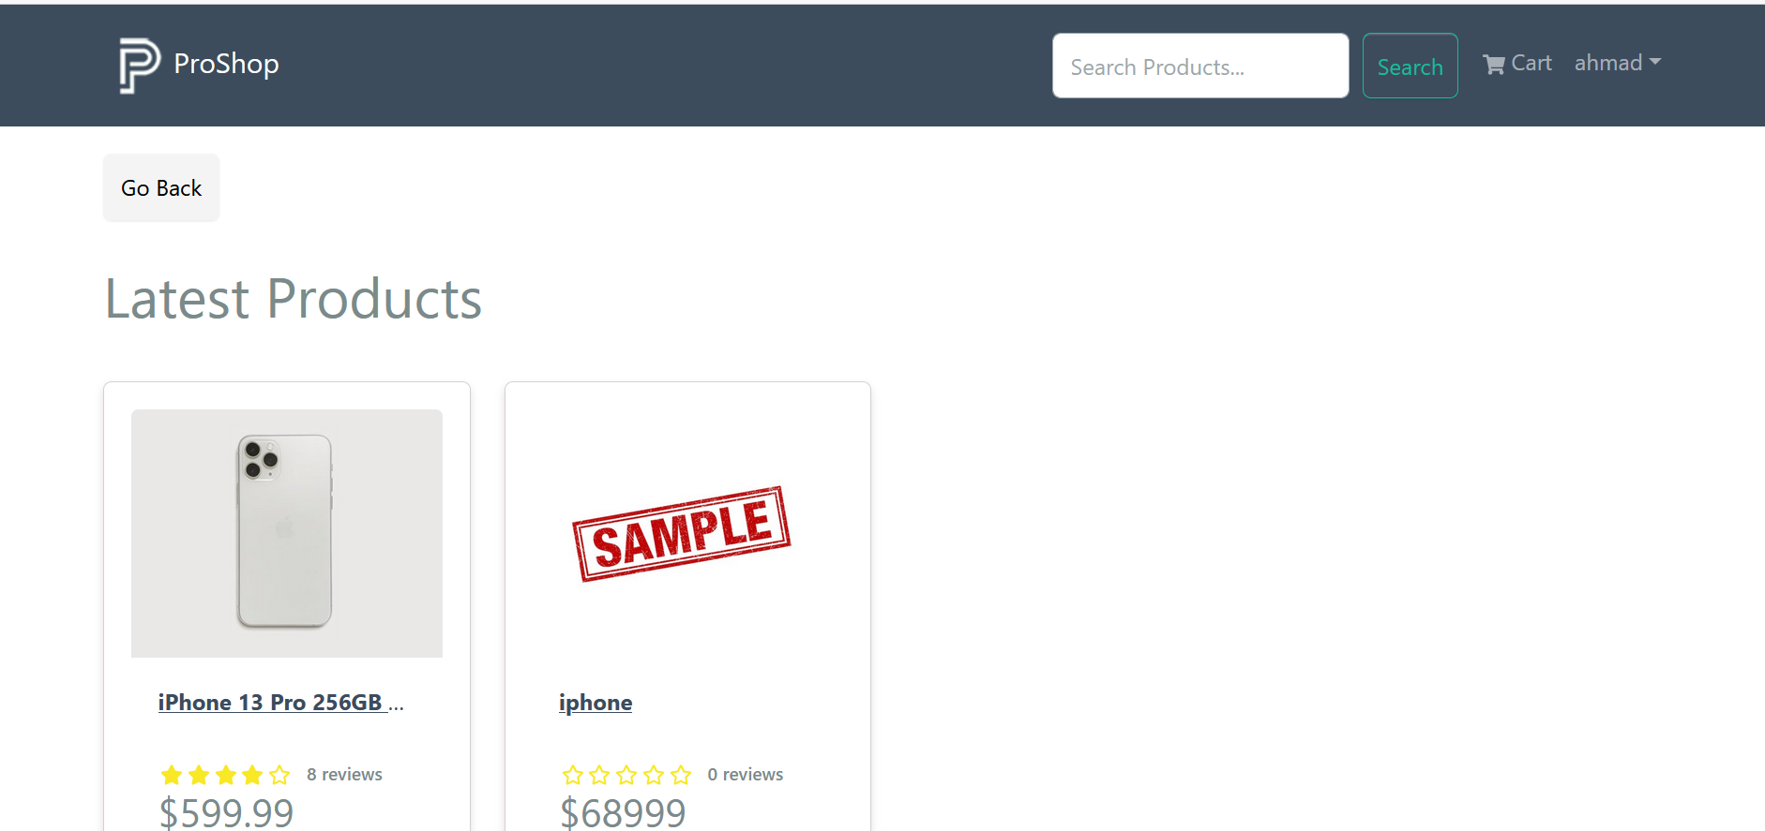

Admin Access

Module 1: Admin Dropdown Access
TC ID | Test Case | Test Data | Expected Result
AD-01 | Admin login | Login with admin account | Admin dropdown is visible
AD-02 | Normal user login | Login with customer account | Admin dropdown is not visible
AD-03 | Guest user access | Open website without login | Admin dropdown is not visible
AD-04 | Click Admin dropdown | Admin user clicks Admin menu | Products, Orders, Users options appear
AD-05 | Click outside dropdown | Dropdown opened | Dropdown closes properly
AD-06 | Refresh page after admin login | Logged-in admin | Admin dropdown remains visible
Module 2: Admin Products Access
TC ID | Test Case | Test Data | Expected Result
AP-01 | Open Products page as admin | Click Admin → Products | Product list page opens
AP-02 | Open Products as normal user | Direct URL /admin/productlist | Access denied or redirect
AP-03 | Open Products as guest | Direct URL /admin/productlist | Redirect to Sign In
AP-04 | Refresh Products page | Admin user | Page loads correctly
AP-05 | Browser back from Products | Admin user | Previous page opens
AP-06 | Products option visibility | Admin dropdown | Products option is shown only for admin
Module 3: Admin Orders Access
TC ID | Test Case | Test Data | Expected Result
AO-01 | Open Orders page as admin | Click Admin → Orders | Orders table is displayed
AO-02 | Verify order columns | Admin order list | ID, User, Date, Total, Paid, Delivered, Details shown
AO-03 | Open order details | Click Details | Order detail page opens
AO-04 | Open Orders as normal user | Direct URL /admin/orderlist | Access denied or redirect
AO-05 | Open Orders as guest | Direct URL /admin/orderlist | Redirect to Sign In
AO-06 | Empty orders list | No orders available | Empty list or proper message shown
Module 4: Admin Users Access
TC ID | Test Case | Test Data | Expected Result
AU-01 | Open Users page as admin | Click Admin → Users | Users table is displayed
AU-02 | Verify user columns | Admin user list | ID, Name, Email, Admin status shown
AU-03 | Edit normal user | Click edit icon | User edit page opens
AU-04 | Delete normal user | Click delete icon | User is removed after confirmation
AU-05 | Open Users as normal user | Direct URL /admin/userlist | Access denied or redirect
AU-06 | Open Users as guest | Direct URL /admin/userlist | Redirect to Sign In

Module 5: Role-Based Access Control
TC ID | Test Case | Test Data | Expected Result
RB-01 | Admin role access | Admin account | Admin pages accessible
RB-02 | Customer role access | Customer account | Admin pages blocked
RB-03 | Guest access | No login | Admin pages blocked
RB-04 | Expired token | Expired session | User redirected to login
RB-05 | Logout admin | Click logout | Admin access removed
RB-06 | Access admin URL after logout | Direct admin URL | Redirect to Sign In
Module 6: Admin Navigation Security
TC ID | Test Case | Test Data | Expected Result
NS-01 | Direct admin URL access | /admin/orderlist | Only admin can access
NS-02 | Browser back after logout | Back button | Admin page should not be accessible
NS-03 | Page refresh on admin route | Admin logged in | Data remains visible
NS-04 | Page refresh as non-admin | Customer logged in | Redirect or access denied
NS-05 | Modify URL manually | Any admin URL | Unauthorized user blocked
NS-06 | Admin menu hidden from customer | Customer account | No Admin dropdown shown
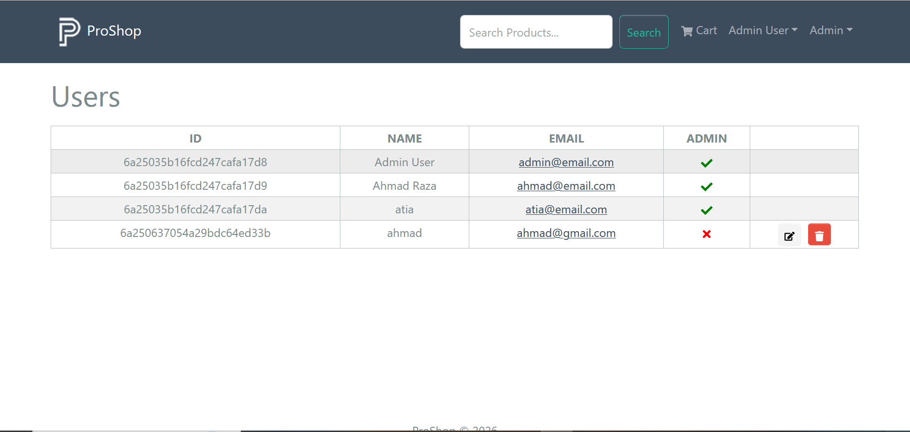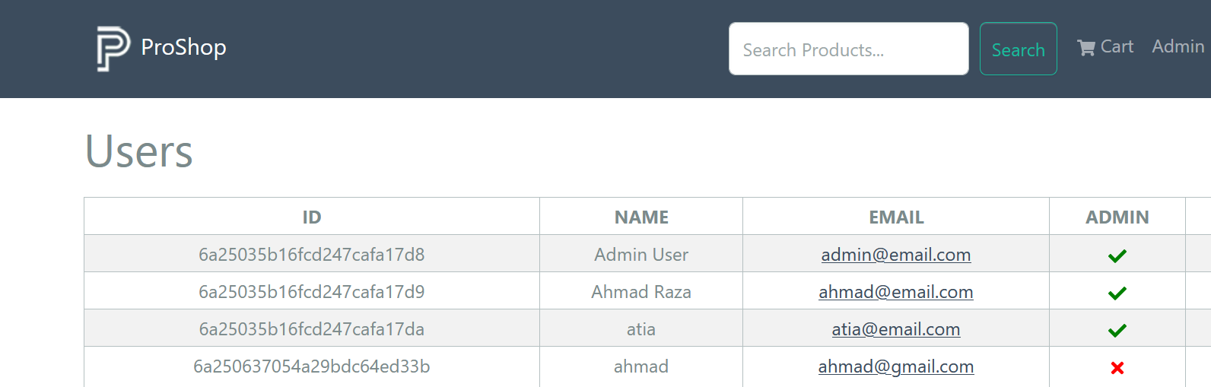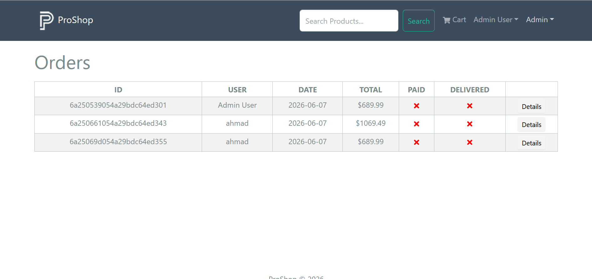

WHITE BOX TESTING

White Box Testing Type | Module
Statement Coverage | User Login Module
Branch Coverage | Product Details Module
Condition Coverage | User Registration Module
Path Coverage | Cart Management Module
Loop Testing | Product Listing / Product Search Module
Cyclomatic Complexity Analysis | Order Placement / Checkout Module

Module 1

Statement Coverage: User Login
TC ID | Test Case | Input Data | Expected Result | Statements Covered
SC-01 | Login with valid credentials | Registered email + correct password | User login successful | User search, password match, token generation, response return
SC-02 | Login with wrong password | Registered email + wrong password | Error message displayed | User search, password check, error response
SC-03 | Login with unregistered email | Email not found | Error message displayed | User search, error response
SC-04 | Login with empty email | Blank email + password | Error/validation response | Request read, user not found, error response
SC-05 | Login with empty password | Email + blank password | Error/validation response | Request read, password check fail, error response
SC-06 | Login with both fields empty | Blank email + blank password | Error/validation response | Request read, user not found, error response

Coverage Result
Coverage Type | Result
Statement Coverage | Covered
Minimum Test Cases Required | 6
Total Test Cases Prepared | 6
Module Status | Pass
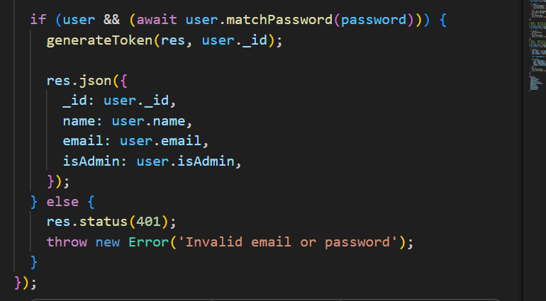

Module 2

Branch Coverage: Login Authentication
TC ID | Branch Tested | Input Data | Expected Result
BC-01 | True Branch | Registered email + correct password | Token generated and user data returned
BC-02 | False Branch | Registered email + wrong password | Status 401 and error message displayed
BC-03 | False Branch | Unregistered email + any password | Status 401 and error message displayed
BC-04 | False Branch | Empty email + valid password | Status 401 and error message displayed
BC-05 | False Branch | Valid email + empty password | Status 401 and error message displayed
BC-06 | False Branch | Empty email + empty password | Status 401 and error message displayed
Branch Coverage Result
Total Branches | Covered Branches | Coverage
2 | 2 | 100%
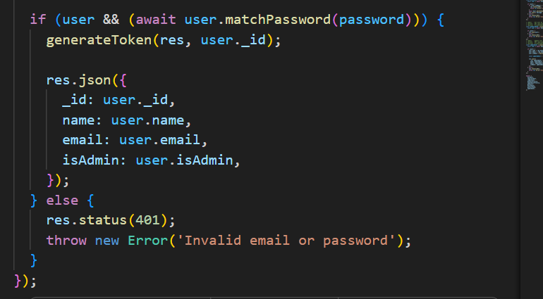

Module 3

Path Coverage: Cart Module
TC ID | Path Tested | Input Data | Expected Result
PC-01 | Add new product path | Product not already in cart | Product is added to cart
PC-02 | Existing product path | Same product added again | Quantity is updated
PC-03 | Quantity update path | Change quantity from 1 to 2 | Cart quantity updates
PC-04 | Remove one item path | Click delete icon | Selected item removed
PC-05 | Empty cart path | Remove all items | Cart becomes empty
PC-06 | Price calculation path | Product price × quantity | Subtotal updates correctly

Path Coverage Result
Total Main Paths | Covered Paths | Coverage
6 | 6 | 100%
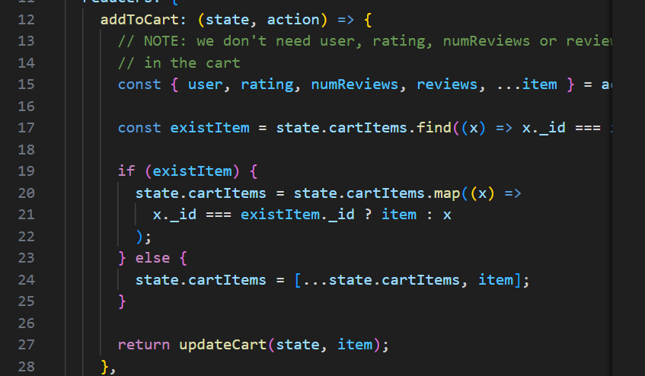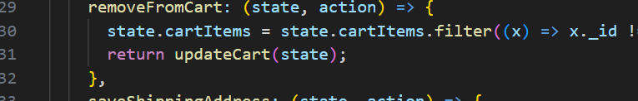

Module 4

Loop Testing: Product Listing / Product Search
TC ID | Loop Tested | Input Data | Expected Result
LT-01 | Zero iteration | No products found | No product card displayed / message shown
LT-02 | One iteration | One product available | One product card displayed
LT-03 | Multiple iterations | Multiple products available | All product cards displayed
LT-04 | Search loop with valid keyword | iphone | Matching products displayed
LT-05 | Search loop with invalid keyword | xyzabc | No matching product displayed
LT-06 | Large product list loop | Many products available | Product list loads without breaking
Loop Testing Result
Loop Type | Covered Cases | Coverage
Product rendering loop | Zero, one, multiple, large data | Covered
Product search loop | Valid and invalid keyword | Covered

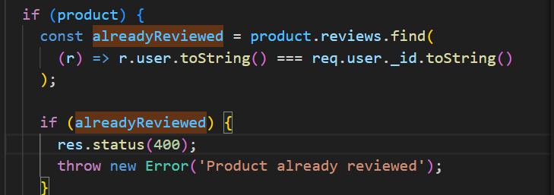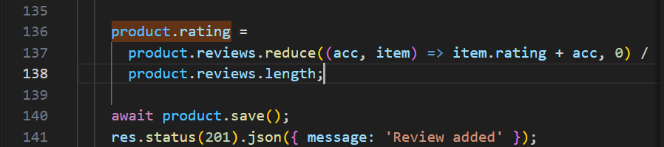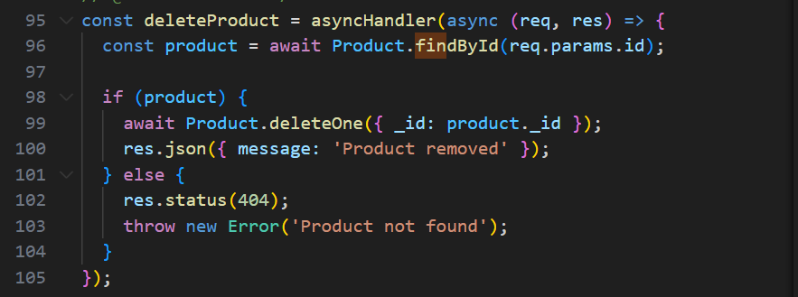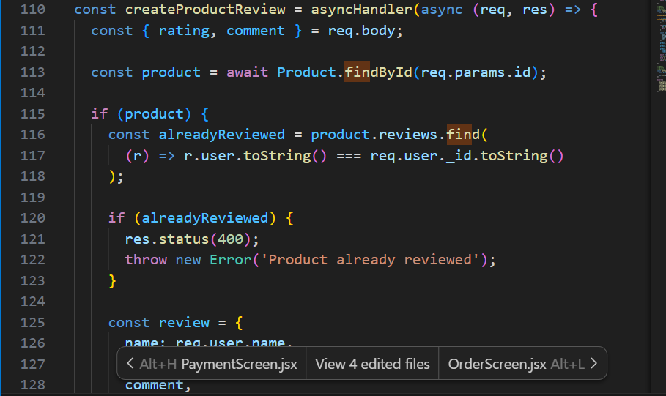
Module 5

Basis Path Testing: Product Management
Basis Path Testing Test Cases
TC ID | Independent Path | Input Data | Expected Result
BPT-01 | Product found path | Valid product ID + updated data | Product details updated successfully
BPT-02 | Product not found path | Invalid/non-existing product ID | Error: Product not found
BPT-03 | Update name path | Valid ID + new name | Product name updated
BPT-04 | Update price path | Valid ID + new price | Product price updated
BPT-05 | Update stock path | Valid ID + new countInStock | Product stock updated
BPT-06 | Update all fields path | Valid ID + all fields changed | Complete product updated
Basis Path Result
Total Independent Paths | Covered Paths | Coverage
2 main paths | 2 | 100%
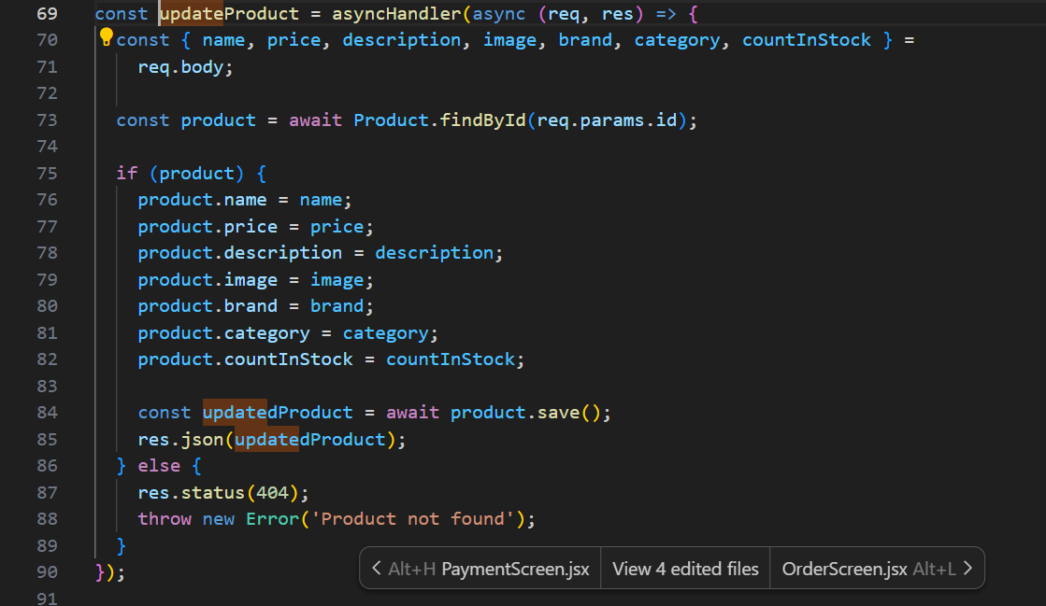

Module 6

Cyclomatic Complexity Analysis: Product By ID
Formula:
V(G) = Number of decision statements + 1
In this function:
Decision Statement | Count
if (product) | 1
So:

V(G) = 1 + 1 = 2
Independent Paths
Path ID | Path Description | Expected Result
Path 1 | Product exists | Product details returned
Path 2 | Product does not exist | 404 error: Product not found

Test Cases
TC ID | Path Tested | Input Data
CC-01 | Path 1 | Valid existing product ID
CC-02 | Path 2 | Valid but non-existing product ID

Result
Total Decision Nodes | Cyclomatic Complexity | Minimum Test Cases Required
1 | 2 | 2

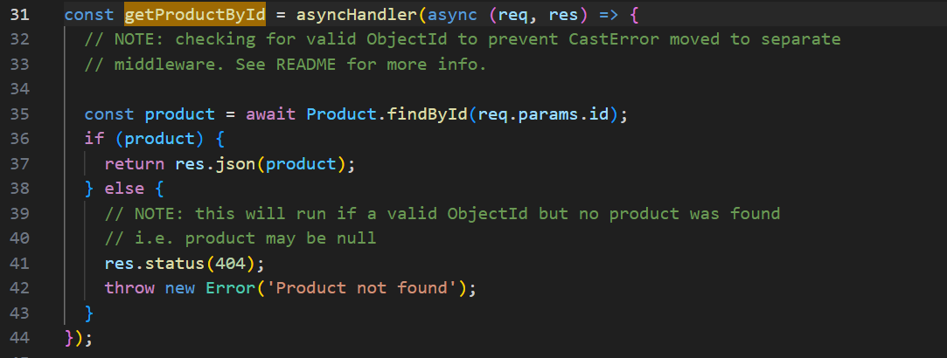

MANUAL TESTING

